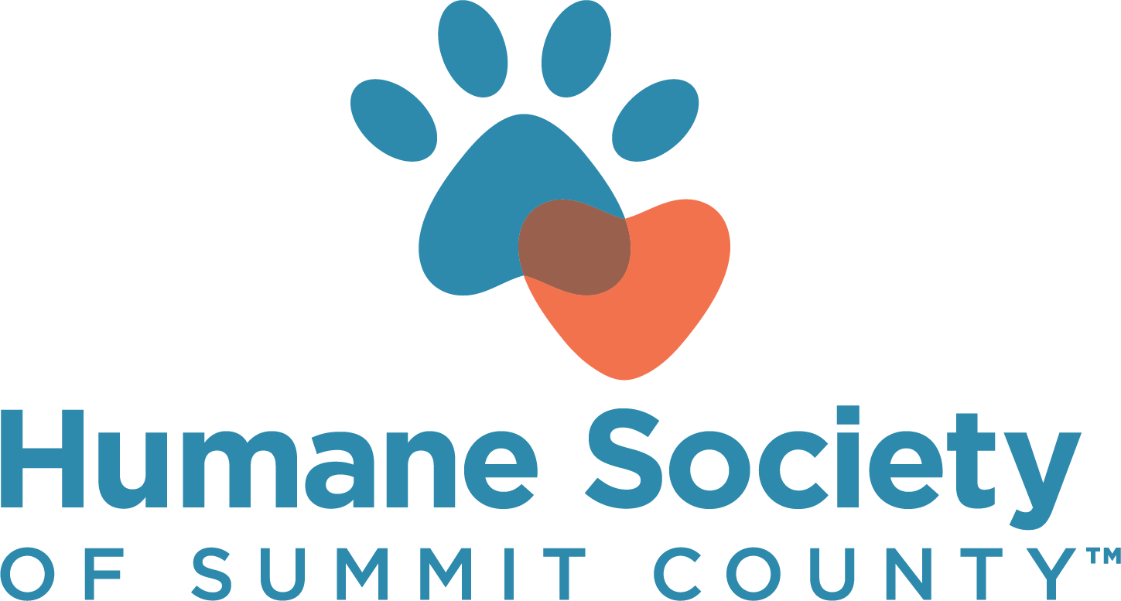

2024 BASKET RAFFLE & AUCTION ITEM DONATION FORM

Date:

YES, I/my company would like to donate the following item(s) for use in any of HSSC’s events.

YES, I/my company would like to donate the following item(s) for use in a specific event. (Please indicate if you’d prefer Bow Wow Bing or the Pawsibility Ball below.)

______________________________________________

YES, I/my company would like to donate the following item(s) for the gift bag pull at the Pawsibility Ball.

We are unable to donate an item, but would like to make a donation in the amount of $________

Please send me information about event tickets or sponsorship opportunities.

Description of item(s):

______________________________________________________________________

______________________________________________________________________

Fair market value of item(s): $

Contact Person: ______________________________________________________

Company Name: ______________________________________________________

Email Address: ________________________________________________________

Phone Number: ________________________________________________________

Mailing address: ________________________________________________________

Signature__________________________________________________Date:________

CONFIRMATION OF YOUR SUPPORT IS REQUESTED 90 DAYS PRIOR TO EVENT TO BE LISTED IN THE EVENT PROGRAM.
Please mail your item and this form to:
Humane Society of Summit County | 7996 Darrow Rd. Suite 30, Twinsburg, OH 44087 | Attn: Heather Hunter
You may also call 234-212-9826 to arrange a pickup | THANK YOU FOR YOUR GENEROUS SUPPORT!

