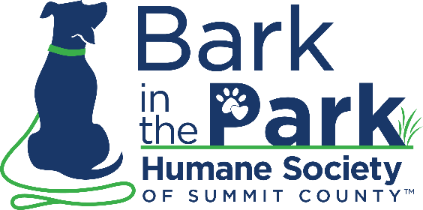
SATURDAY, SEPTEMBER 16, 2023 | 9 AM – NOON | MUNROE FALLS METRO PARK

Bark in the Park Event & Liability Waiver:
In consideration and acceptance of this entry, I, on behalf of myself, my heirs, executors and administrators, hereby waive and release all rights and claims of any nature I (or my child, if I am signing as a parent or legal guardian) may have against the Humane Society of Summit County, and all other supporters or sponsors, their officers, agents, employees, representatives, successors and assigns (collectively referred to as “Sponsor”) for all injuries or death which I (or my child) may suffer in this walk or in any way arising out of my (or my child’s) participation in this walk, including any pre-walk and post-walk activities. I agree to indemnify and hold harmless the Humane Society of Summit County and their agents, officers, employees, and representatives, as well as every Sponsor, from any and all liability, damage or expense (including, without limitation, costs of litigation and attorney’s fees) that any Sponsor may suffer or incur in conjunction with any claims made by me (or my child). Additionally, I will allow free use of my name and photograph (or that of my child) for broadcast or print if taken to publicize the event. I am (or my child is) physically fit and sufficiently trained for this event, and I do not request any person or organization involved in any way with this event to attempt to verify or confirm that I am (or my child is) fit to participate in this event. I am and will remain absolutely and solely responsible for any actions of any animals I (or my child) bring to this event.
I further agree that I (or my child) will not swim, bathe, wade, enter into, or use personally owned watercraft in any park waters except in the areas and at times designated by the Executive Director of the Summit Metro Parks.

Signature: ___________________________________________________________
Print Participant Name: _________________________________________________
Relationship to Participant (if other than self): ________________________________
HSSC Representative: ________________________________________________
Date: __________________

