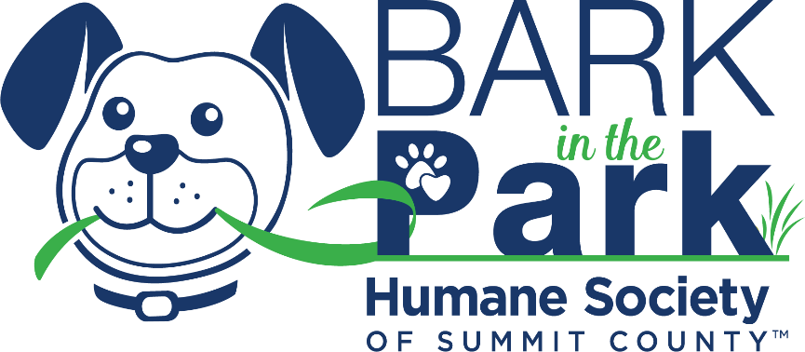
Email Template

Subject line: I’d love your support to help save lives!
Dear [insert their name],
Thanks for taking a few minutes out of your busy day! I’m writing because the Humane Society of Summit County, an organization close to my heart, is fundraising for the Bark in the Park Rescue Walk and I have committed to being a Rescue Walk Fundraiser! I have set a personal goal of raising [personal fundraising goal $] to contribute to the overall goal of raising $25,000 in support of the lifesaving veterinary care that the animals of Summit County need.
[If you want to include a personal fundraising story here, but if you don’t then remove this line: why you’ve decided to support this walk and your connection to the cause.]
It would mean a lot to me, and the 2,500 animals rescued each year, if you can make a donation to my personal page to help me accomplish my fundraising goal. Donating is easy, simply follow the link to my campaign page here: [link] or you can text [PERSONAL TEXT TO DONATE CODE] to the number 71777!
If donating online isn’t your style, you can donate by cash or check, just simply ask me how.
I would also like to extend an offer for you to save the date for Bark in the Park – Saturday, May 21, 2022 at Lock 3 in Akron from 11am-3pm. This event is the biggest celebration of pets and the people who love them and you can join me in supporting the lifesaving mission of HSSC.
I have chosen to walk for those with no voice – will you support me and the animals?
For all our furry friends at the Humane Society of Summit County, we than kyou in advance for your support!
Sincerely,
[Your name]

