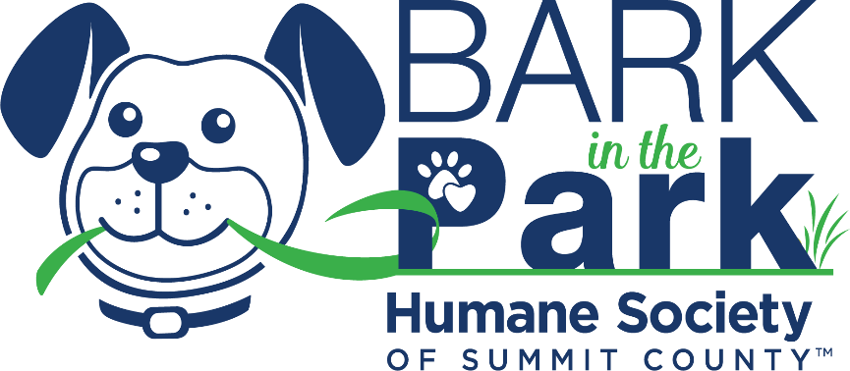
Sample of Social Media Posts
*Don’t forget to copy your fundraising URL page or your text to donate code into each caption so potential donors can go directly to your page.
*Helpful URLs to know & use:
Website: www.summithumane.org/bitp
Mobile Cause Fundraising Site: https://bit.ly/RescueWalk22
Facebook: https://www.facebook.com/summithumane/
Instagram: https://www.instagram.com/summithumane/

*You may use any of the photos or graphics we have in our PHOTOS & GRAPHICS folder.

- I am excited to support the Humane Society of Summit County by raising [personal $ goal] for the Bark in the Park Rescue Walk this year! All the proceeds from the Rescue Walk support veterinary care provided to the 2,500 rescued animals of Summit County. Will you help support this cause that is close to my heart? [Insert Personal Link to page]. #BITPWalk

- WE WALK FOR THOSE WITH NO VOICE. The Humane Society of Summit County has set of goal of raising $25,000 to support lifesaving Veterinary Care through the Bark in the Park Rescue Walk - we need your help to do it!

Every dollar raised helps the animals in need. Will you donate to my personal fundraising page today and help achieve my goal of [insert personal goal]? You may donate online here [Insert Personal Link to page] or pledge an offline gift of a check or cash to me. #BITPWalk

- I am fundraising on behalf of the Humane Society of Summit County through their Bark in the Park Rescue Walk because [share reasons why you are fundraising and your personal connection to the cause].

I have seen firsthand the positive impact of their work and I have set a personal goal of raising [$ amount] to help reach the $25,000 goal set. The money we raise together will support lifesaving veterinary care provided to the 2,500 rescued animals of Summit County.

Please join me in my mission to support the Humane Society of Summit County by donating any amount to my personal fundraising page [Insert Personal Link to page]. #BITPWalk

- Now through Saturday, May 21st, the Humane Society of Summit County is hosting the Bark in the Park Rescue Walk! I have chosen to become a Rescue Walk Fundraiser on behalf of the 2,500 animals rescued each year and to make a difference in our community, one life at a time. Join me and become a fellow Rescue Walk Fundraiser, or please consider donating to my personal page at [Insert Personal Link to page]. Every dollar helps! #BITPWalk

