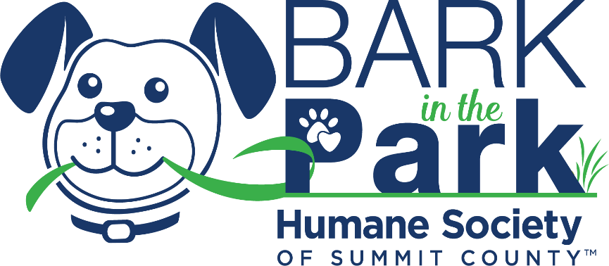
Phone Script Thank You Call

Hello [say their name]
I wanted to call to thank you for your recent donation made to my fundraising page in honor of the Bark in the Park Rescue Walk! Your donation of [say their donation amount] will directly support the veterinary care rescued animals of Summit County need.
Please feel free to share my Rescue Walk Fundraising Page URL with your family, friends, or coworkers to help multiply the donations!
The rescued animals and I thank you!

