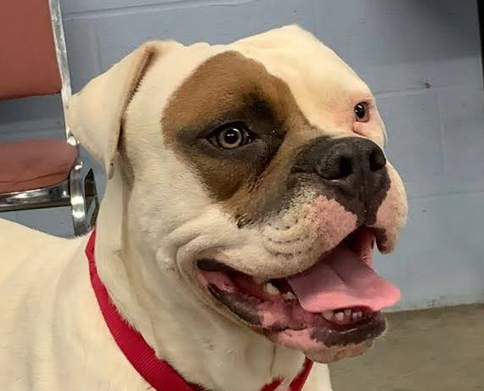
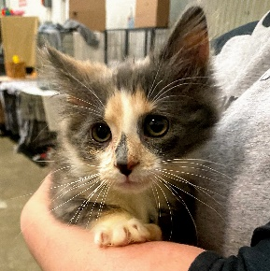

AUCTION ITEM DONATION FORM

Date:

⃝ YES, I/my company would like to donate item(s) to the Reverse Ruffle & Auction.

⃝ I would like to make a donation in the amount of: $ ______

⃝ I would like to purchase Reverse Ruffle tickets ($50 each, you will be contacted with your number(s) and how to follow the drawing.) Number of tickets ______
Description of item(s): ______

Fair market value of item(s): $

Contact Person:

Company Name:

Email Address:

Phone Number:

Mailing address:

CONFIRMATION OF YOUR SUPPORT IS REQUESTED BY MARCH 1, 2021 TO BE LISTED ON THE EVENT WEBSITE & AUCTION SITE.
A RECEIPT WILL BE MAILED TO YOU FOLLOWING THE CONCLUSION OF THE REVERSE RUFFLE & AUCTION.

Please mail your item and this form to:
Humane Society of Summit County
Attn: Carli Molinelli
7996 Darrow Rd, Ste. 30
Twinsburg, OH 44087
You may also call 234-212-9826 to arrange a pickup | THANK YOU FOR YOUR GENEROUS SUPPORT!

